# Simple GLITC User Manual

You need:

1. GLITC firmware (glitc_top_v2.bit)
2. ChipScope running with a connection to the device
3. Python

## Program GLITC

Note: “dev = tisc.TISC()” selects /sys/class/uio/uio0 as the path to the device. You can also pass a path to the device (e.g. dev = tisc.TISC(“/sys/class/uio/uio1”)). Make sure your permissions allow you to access “config”, “resource0”, and “resource1” under the path to the device.

Python 2.7.9 (default, Mar 1 2015, 12:57:24)

[GCC 4.9.2] on linux2

Type "help", "copyright", "credits" or "license" for more information.

>>> import tisc

>>> dev = tisc.TISC()

>>> dev.gprogram(0, “glitc_top_v2.bit”)

## Initialize datapath

>>> dev.GA.datapath_initialize()

## Enable the phase scanner

>>> dev.GA.write(0x40, 0x1)

## Find a crude operating point

>>> dev.GA.rdac(0, 32, 3500)

>>> dev.GA.rdac(0, 31, 1700)

>>> dev.GA.rdac(1, 32, 3500)

>>> dev.GA.rdac(1, 31, 1700)

The “rdac” function loads the RITC DAC. The first parameter specifies the RITC, and the second specifies the DAC number. DAC #32 is VDD (the less sensitive parameter). DAC #31 is VSS (the sensitive parameter).

## Verify crude operating point

>>> dev.GA.counters()

Channel 0: 512

Channel 1: 512

Channel 2: 512

Channel 3: 512

Channel 4: 512

Channel 5: 512

If the counters are not identically 512, try raising/lowering VSS (DAC #31) until they are.

## Load phase scanner ChipScope setup

Filename is “phasescanner.cpj” in “glitc_debug” in the firmware repository.

## Switch to phase scanner debug inputs in ChipScope

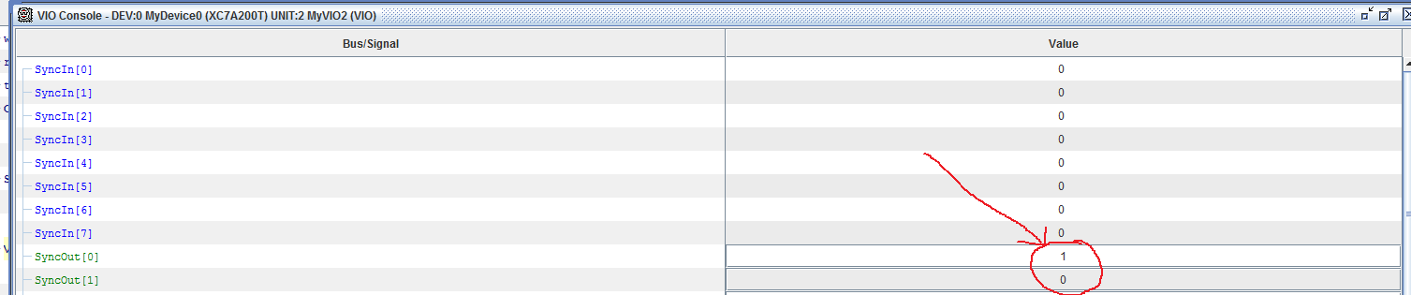

## Enter “repetitive trigger mode” on phase scanner ILA (ILA0)

You should see something like this:

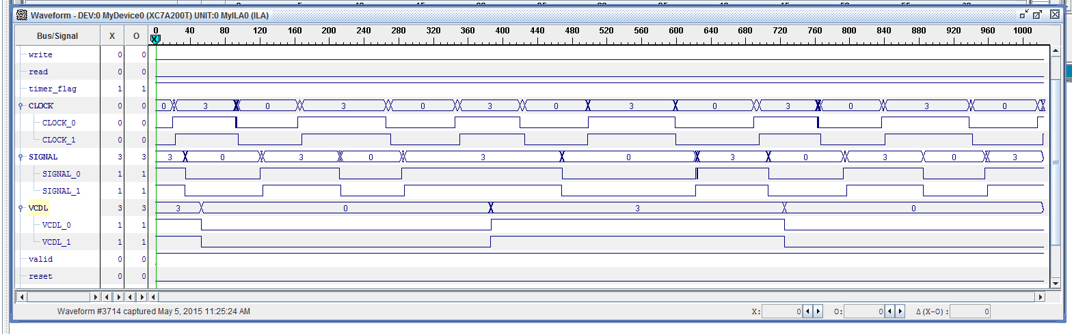

## Fine tune the operating point

The goal of the fine tune is to make the *width of the last bit* in the training pattern equal to 84 samples. This is because each step is (1/(975 MHz*56)) = 18.3 picoseconds, and 84*18.3 picoseconds is 1537.2 ns, equal to 650 MHz (the bit rate of the data out of the TISC). Put another way, there are 672 (56 steps in 1 VCO period, and 12 VCO periods in 1 VCDL period) steps in a full VCDL cycle, and 8 total bits. 672/8 = 84.

The last bit is indicated with the X/O cursors in the next diagram

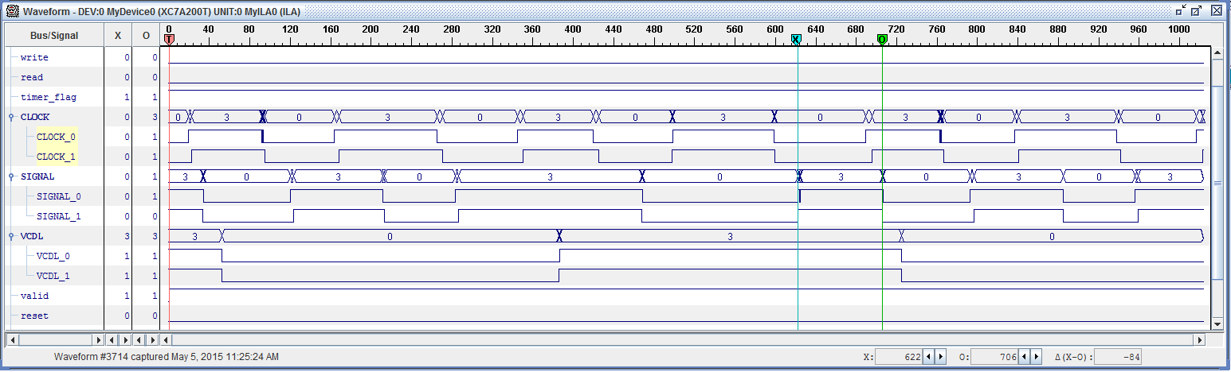Note that ChipScope specifies the X-O distance in the bottom right corner, which helps.

Raise/lower VSS (DAC #31) as needed until the bit width is 84 samples.

## Autotune the data capture

Once a fine operating point has been found, the data capture can be automatically tuned:

>>> dev.GA.eye_autotune_all()

eye_autotune: setting to delay 11

eye_autotune: bitslipping 0 times

… (repeat for all bits/channels)

Note that in normal operation the bitslip count (“bitslipping 0 times”) will be 2 the *first time* after programming. After that the bitslip count should always be 0. This is because the ‘bitslip count’ is remembered.

## Disable training

To actually view proper RITC data rather than training data, training must be disabled with:

>>> dev.GA.training_ctrl(0)

At this point you can view *individual samples* in the VCDL period with

>>> dev.GA.train_read(channel, sample, 1)

Channel must be (0,1,2) or (4,5,6). Sample must be between 0-31. The final ‘1’ puts “train_read” in ‘sample view’ mode, where the bits are captured as 3-bit samples rather than the 8 bits that a given LVDS pair puts out per VCDL cycle.

After power on, most likely all samples will read out “7”, since the comparators will all be set to 0.

## Tune the thresholds

At this point the comparator thresholds can be tuned. The input value can be set using the DAC, via

>>> dev.GA.dac(channel, value)

“Channel” here should be 0,1,2 or 4,5,6. “Value” here should be 0-2000, which converts into millivolts via (value*2500/4095).